

Manual
Use manual ROOF SCAFFOLD
Version: 1.0
Date: 09-02-2016

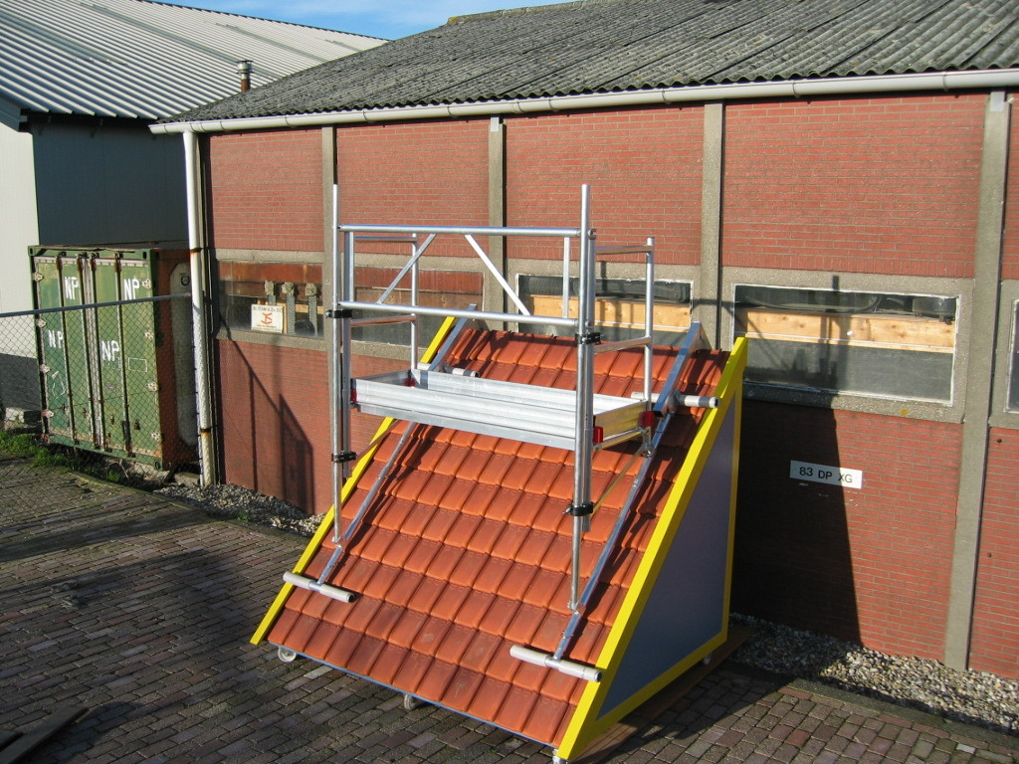

All rights reserved. Nothing in this release
may be reproduced, stored in a
computerised database, or public
Made, in any form or by any means, or
Electronic, mechanical, photocopies,
Recordings, or any other way, without
Prior consent of ASC Group
This publication may only be used for
ASC Group Products.

Set and print errors are reserved.

For more information:
076-5413019

Index

Maximum Load 3
Compund list 4
Parts description 5
Construct instrucions 6 to 8
Example setups (schematic) 9

Standard configuration Range

The working platform of the Roof scaffold in the standard configuration can be placed at least 0.50 meters from the roof. This distance can be extended as required, depending on the situation.

Maximum Load

The maximum load of the Roof scaffold is 250 kg with even dispersion. The roof has to have sufficient capacity, check beforehand if the roof scaffold can be placed on the construction.
When building the Roof scaffold, always use a life-line.

Compound List single Roof scaffold (on one side of the roof)

Distance of Cam & type parts* |  | Some Roof scaffold
 | Article nr. | 0,5 | 2,05 – 2,90 | 2,90 – 4,15 | 4,00 – 5,25 | 5,15 – 6,40 | 6,25 – 7,50 | 7,40 – 8,65
Nokstuk | 70801100 | 2 | 2 | 2 | 2 | 2 | 2 | 2
Voetligger – vloerdrager ¹ | 70801200 | 2 | 2 | 2 | 2 | 2 | 2 | 2
middlebeam (140 cm.) | 70801300 | - | 2 | 2 | 2 | 2 | 2 | 2
Short Topbeam (112 cm.) | 70801450 | - | 2 | - | 2 | - | 2 | -
Long topligist (225 cm.) | 70801400 | - | - | 2 | 2 | 4 | 4 | 6
Roof scaffold Saha | 70801500 | 2 | 2 | 2 | 2 | 2 | 2 | 2
Between Slipper (optional) | 70801550 | - | - | - | - | - | - | -
APW Leuningframe 75-2 | 10100102 | 2 | 2 | 2 | 2 | 2 | 2 | 2
Double Handrail Cowl 190² | 10302211 | 1 | 1 | 1 | 1 | 1 | 1 | 1
Platform without Hatch L997 190² | 20203311 | 1 | 1 | 1 | 1 | 1 | 1 | 1
Securingclip | 90609997 | 8 | 12 | 12 | 14 | 14 | 16 | 16
Kantplankset 190x75² | 90607830 | 1 | 1 | 1 | 1 | 1 | 1 | 1

Compound list Double Roof scaffold (on two sides of the roof)

Distance of Cam & type parts* |  | Some Roof scaffold
 | Article nr. | 0,5 | 2,05 – 2,90 | 2,90 – 4,15 | 4,00 – 5,25 | 5,15 – 6,40 | 6,25 – 7,50 | 7,40 – 8,65
Nokstuk | 70801100 | 2 | 2 | 2 | 2 | 2 | 2 | 2
Voetligger – vloerdrager ¹ | 70801200 | 4 | 4 | 4 | 4 | 4 | 4 | 4
middlebeam (140 cm.) | 70801300 | - | 4 | 4 | 4 | 4 | 4 | 4
Short Topbeam (112 cm.) | 70801450 | - | 2 | - | 2 | - | 2 | -
Long topligist (225 cm.) | 70801400 | - | - | 4 | 4 | 8 | 8 | 12
Roof scaffold Saha | 70801500 | 4 | 4 | 4 | 4 | 4 | 4 | 4
Between Slipper (optional) | 70801550 | - | - | - | - | - | - | -
APW Leuningframe 75-2 | 10100102 | 4 | 4 | 4 | 4 | 4 | 4 | 4
Double Handrail Cowl 190² | 10302211 | 2 | 2 | 2 | 2 | 2 | 2 | 2
Platform without Hatch L997 190² | 20203311 | 2 | 2 | 2 | 2 | 2 | 2 | 2
Securingclip | 90609997 | 16 | 24 | 24 | 28 | 28 | 32 | 32
Kantplankset 190x75² | 90607830 | 2 | 2 | 2 | 2 | 2 | 2 | 2

* Distance measured from coping to beginning of platform
1 including 2 rotary couplings
2 longer lengths up to 8 meters possible (use e.g. ALU work bridges)!

Parts description

Nokstuk (fig. 1)
Modelno. 70801100
The Coping bracket is placed over the ridge. Here the other parts of the Roof scaffold are attached to it.

Topbeams (fig. 4)
Artikelnr. Short topbeam 112 cm.: 70801450
Modelno. Long topbeam 225 cm.: 70801400
The Topbeam is a tube of 112 or 225 cm. length. These can be attached directly to the Nokstuk. To work lower on the roof, several topbeams can be attached to each other.

middlebeam (fig. 3)
Modelno. 70801300
The Middbeam is a set tube of 168 cm. With 11 holes every 14 cm. The middlebeam is used between the Topbeam and the floor carrier.

Foot-beam – floor carrier (Fig. 2.1 and 2.2 together)
It can be placed immediately after the coping bracket or after the middlebeam. The floor carrier can be adjusted in any desired degree angle by using 2 adjustment points.

TIP: You can also use multiple floor carriers in a single set-up, for example to work with chimney and dormer.

Rotating coupling
Guardrail frame
Platform
Floor carrier
Footbeam

Roofbeams

Modelno. roofbeam: 70801500
Modelno. tussenslof: 70801550

The Roofbeam can be fixed at the bottom of the Roof scaffold. This makes the weight of the roof scaffold evenly distributed so that the roof itself is not damaged.
The intermediate beam can be placed in front of the floor carrier if the beams bend too much.

Place 2 Coping brackets at the desired distance on the ridge of the roof, in such a way that on both sides of the coping the roofbeam rests across multiple heights of the rooftiles.
The Coping bracket can be used on roofs with a slope of 30 to 60 degrees.

Note that the first item you place in the coping bracket is blocking the U profile. The tube cannot go up and down.

Are you working at the top of the roof?

When you are going to work e.g. on a chimney, you attach the floor carrier (directly to the Coping bracket. You slide the floor carrier into the U-profile at the end of the Coping bracket and lock it with a securing clip.
The work floor is now 0.50 meters from the coping. See the picture on the right side.

Are you working lower on the roof?
By mounting one or more topbeams to the Coping bracket you can extend the roof scaffold as far down as is necessary. The beams guarantee you with Securing clips.
When mixing short and long topbeams, it is best to use the long topbeams at the bottom. The adjustment options of the middlebeams are better this way.

Fine tuning

To fine tune the length from ridge to platform, use the middlebeam. It is placed as a connecting tube between the lower Topbeam and the floor carrier. The middlebeam is equipped with 11 holes every 14 cm. and therefore a total of 1.40 meters adjustable
When using multiple top and middlebeams, the setup can bend slightly. To avoid this, you can place between the floor carrier and the middlebeam a slipper. The weight is so better distributed so that the roof is not damaged.
Floor carriers
Then set the floor carriers (Fig. 2.1 and 2.2) so that the platform will be horizontal. This adjustment depends on the slope.
Tip: It is advisable to adjust the floor carrier in the right corner beforehand, for example on a lower roof deck. To adjust the final height can also, but is more difficult and takes more time.

- Loosen one half of the bottom rotary coupling.
- Remove the Securing clip from the bottom tube.
- The Triangle section (Fig. 2.2) and the lower tube (Fig. 2.1) can now be easily adjusted (see picture below).
- Place the triangle part in the correct position relative to the roof deck, make sure that the upper tube is horizontal. This is where the platform is located.
- Set the length of the lower tube so that the vertical tube runs straight up next to the triangle area.
- Fixate the whole by reinserting the Securing clip back into the appropriate hole and clamping the rotary coupling again on the vertical tube.

- Place the Roofbeams at the bottom of the floor carrier and attach it with a Securing clip.
- Place a platform (Fig. 5) or work Bridge on the floor carriers (Fig. 2.2).
- Place the handrail frames 75-2 on the floor carriers and fix them with a rotary coupling.
- Apply the double handrail to the vertical tubes. The height must lie approximately equal with the sports of the kopleuning.
- This will connect the two floor carriers and make them completely stable.
- now place a kantplankset along the work floor
The Roof scaffold is now ready for use.
We thank you for the confidence in our product and wish you a lot of work pleasure.

For questions about safe use, proper maintenance, repair and replacement of spare parts, always consult your supplier or manufacturer.

